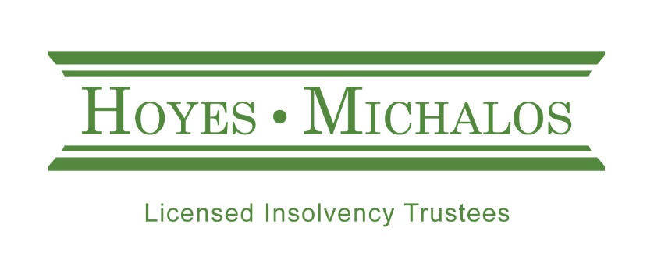

Joe Debtor 2018

No Room to Maneuver
Hoyes, Michalos & Associates Inc. is one of Canada’s largest personal insolvency firms, focused solely on helping individuals restructure their debt through personal bankruptcy or a consumer proposal.
As required by law, we gather a significant amount of information about each person who files with us. We examine this data to develop a profile of the average person who files for relief from their debt (we call this person “Joe Debtor”). We use this information to gain insight and knowledge as to why consumer insolvencies occur. Our 2018 study, now updated annually, reviewed the details of more than 4,200 personal insolvencies in Ontario from January 1, 2018, to December 31, 2018 and compared the results of this profile with study results conducted since 2011 to identify any trends.
Our 2018 study is divided into two components:
- Key findings
- A profile of the average insolvent debtor

Key Findings: No Room to Maneuver

Millennials Are the Fastest Growing Cohort Filing Insolvency
On average, Joe Debtor is 43 years old however it is Millennials1 who are filing insolvency at a much faster rate; faster than their entry into the workforce would seem to warrant.
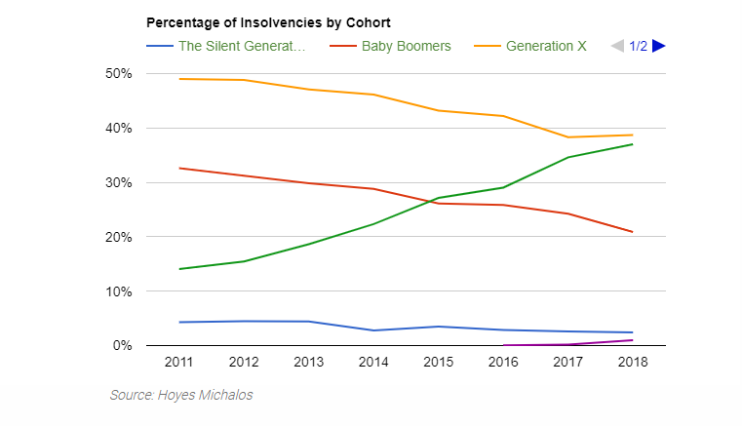
Source: Hoyes Michalos
In 2011, when the youngest Millennial was 15, only 28% of the Canadian workforce2 was Millennials. By 2018, with Millennials now aged 22 to 37, their cohort accounted for 34% of the Canadian workforce, an increase of 22%. During this same period, however, Millennials filing insolvency increased from 14% of insolvencies to 37% of insolvencies; an increase of 162%.
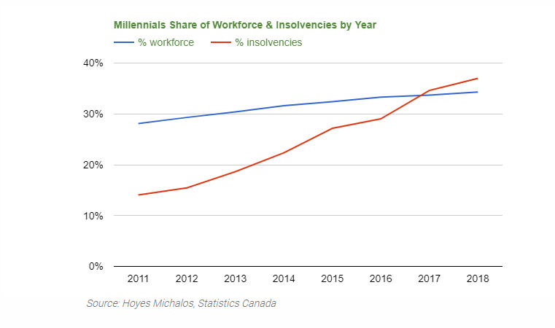
Source: Hoyes Michalos, Statistics Canada
Today almost two in five (37%) insolvencies are filed by Millennials. Yes, Generation X still files more insolvencies (39%), but their share of insolvencies has been on the decline, while Millennial insolvencies are rising.
On average, Millennial debtors owe $35,733 in unsecured debt when they file insolvency, the lowest debt level of all cohorts. However, they face an assortment of debt risks, some specific to their generation.
Millennials (aged 22-37) | 2016 | 2017 | 2018
% of all debtors | 29% | 35% | 37%
Unsecured debt | $35,497 | $35,886 | $35,733
Debtor income | $2,155 | $2,275 | $2,431
Unsecured debt-to-income | 137% | 131% | 122%
Likelihood of owning a home | 8% | 4% | 3%
% with student debt | 29% | 26% | 31%
Student debtª | $13,359 | $13,734 | $14,311
% who use payday loans | 35% | 40% | 46%
Payday loan debt^{b} | $2,745 | $3,639 | $4,792
% who use credit card debt | 86% | 86% | 88%
Credit card debt^{c} | $10,539 | $10,956 | $11,716
a - those with student debt, b – those with payday loans, c – those with credit card debt

More than three in ten (31%) Millennial debtors carry student debt. For those who do, their average student loan debt in 2018 was $14,311, an increase of 4.2% over 2017.
Millennials are a generation buried in student loans which is why we are seeing such a dramatic rise in student debt driven insolvencies. In our 2018 study, almost one in five (18%) insolvencies involved student debt with 64% of student debt insolvencies filed by Millennials, followed by Generation X at 31%. Under Canadian bankruptcy law, student loan debt is not automatically discharged by bankruptcy or a consumer proposal unless the debtor has been out of school for at least seven years. Millennials, and GenXers, dealing with student debt have been struggling with repayment for years. As more Millennials, and eventually Post-Millennials pass the 7-year limitation for student debt forgiveness in a bankruptcy or consumer proposal, student debt insolvencies rise.
For more on why student debt is a looming debt crisis, see our 2017 study on Why Student Debt is Contributing to More Insolvencies.
In 2018, almost half (46%) of all Millennial debtors had at least one payday-style loan, up from 40% in 2017. Access to quick, low credit money is perhaps the largest debt epidemic facing Millennials after student debt.
Payday loan companies and online lenders now offer a wider array of easy borrowing options for individuals with poor credit, including larger short-term installment loans and lines of credit. While traditional Ontario payday loans (most of these loans) still charge an effective annual interest rate of 390% effective January 2018, quick cash installment loans for those with poor credit typically cost up to 59.99%3.
Attracted by easy online access and advertising lines like ‘fast & easy’, ‘better than payday loans’ and ‘no documents needed’ and often ‘no credit check required’, Millennials are frequent users.
Millennial debtors using a payday loan now owe a total of $4,792 on 4.1 loans, accounting for 15% of their total debt. Even more alarming, their average payday-style loan size grew from $920 in 2017 to $1,189 in 2018. Meanwhile, 13% of all Millennial fast cash loans were for $2,500 or more, up from 6% in 2017.
For more information on why the payday loan crisis is not abating, and how this impacts all age groups, see our 2018 report on Payday Loans and Bankruptcy.
Another changing trend among Millennial debtors is the return to the use of credit card debt and lines of credit.
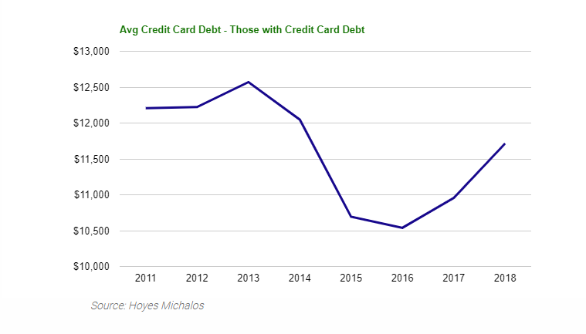
After declining steadily from 2013 to 2016, average credit card debt owed by insolvent Millennials has increased over the past two years.
As Millennials become older, they both apply for more credit cards and increase their credit card limits as their incomes rise. In 2018, Millennials with credit card debt owed an average of $11,716 on 2.5 credit cards, an increase of 6.9% from 2017 balances.
At the same time, their average personal loan balances, which includes unsecured lines of credit, grew 3.8% to $14,370 in 2018.
Millennials don’t limit their credit card use to big-ticket items. They are highly likely to pay for everyday goods and services, including entertainment, groceries, and clothes, as well as make online purchases with credit cards, which can lead to financial problems when credit is used to balance their budget. They often view minimum payments as just another monthly expense to be covered.
After the Silent Generation (those 73 years old and older in 2018), Millennials are the most likely of any cohort to blame financial mismanagement as a primary cause of their insolvency, including the overuse of credit.
Compounding their rising debt levels, Millennials have less income to support their debt. Millennials are working, in fact 88% reported being employed at the time of filing. However, the average Millennial debtor has a take-home pay of $2,431; 3.9% less than the average Joe Debtor and 10.3% less than Generation X.
After paying for housing, transportation and living expenses, Millennials have only $243 available to support unsecured debt repayment (excluding their mortgage and car payment); the lowest of any cohort. This is a problem when the average monthly interest cost on their debt is $1,0334.
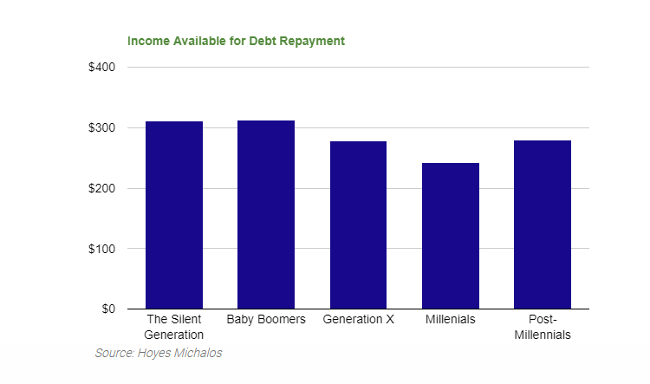Which leads us to the final financial dilemma facing insolvent Millennial debtors. They have no room to maneuver. While the average Millennial debtor income has increased from $2,275 in 2017 to $2,431 in 2018, that growth is not enough to cover debt repayment. In addition, Millennials are less likely to be able to refinance.
The overall trend since 2013, as monitored monthly by our Homeowner’s Bankruptcy Index, has been a decline in the percentage of insolvencies involving homeowners. In 2018, only 5% of all insolvencies involved homeowners, down from 8% in 2017 and a dramatic drop from an annual average of 29% in 2011.
However, Millennials filing insolvency are even less likely to own a home. In 2018, just under 3% of all Millennial debtors owned a home at the time of filing. Having been largely locked out of homeownership, they are unable to refinance their debt at lower rates through any rising equity in their home. And those who have entered the market likely bought at higher prices, limiting their ability to refinance as well. This is illustrated by the fact that, for the small percentage of Millennial debtors with a home, the average equity available in their home was 7% in 2018, compared to 9% for Generation X and 14% for insolvent Baby Boomers.
While the single, most significant trend we see in 2018 is the increased risk of filing insolvency faced by Millennials, many of these debt risks apply to all age groups. Below is a profile of the average insolvent debtor for 2018, by various demographics and credit profile.

Joe Debtor: Profile of the Average Insolvency Debtor
The table below presents a snapshot of today’s average insolvency debtor based on our 2018 annual study, as compared with 2017.
Joe Debtor | 2018 |  |  |  | 2017
Personal information:
Male |  | 51% |  |  | 52%
Female |  | 49% |  |  | 48%
Average age |  | 43 |  |  | 43
Marital status
Married/Common-law |  | 32% |  |  | 34%
Divorced or Separated |  | 23% |  |  | 24%
Widowed |  | 3% |  |  | 3%
Single |  |  | 42% |  | 39%
Average family size (including debtor) |  |  | 2.0 |  | 2.0
Single-person household |  |  | 52% |  | 53%
Likelihood of having dependant(s) |  |  | 35% |  | 34%
Likelihood of being a lone-parent |  |  | 17% |  | 15%
Average monthly income (debtor) |  |  | $2,530 |  | $2,420
Total unsecured debt |  | $49,289 |  |  | $49,071
Unsecured debt-to-income |  | 162% |  |  | 169%
Likelihood they own a home |  | 5% |  |  | 8%
Average mortgage value (homeowner) |  | $221,235 |  |  | $190,343
Detailed Information on the amount of
average unsecured debt:
Personal loans |  | $16,944 |  |  | $17,520
Credit cards |  | $15,905 |  |  | $15,134
Taxes |  | $8,835 |  |  | $8,797
Student loans |  | $2,597 |  |  | $2,089
Other |  | $5,008 |  |  | $5,531
Filed bankruptcy |  | 36% |  |  | 39%
Filed consumer proposal |  | 64% |  |  | 61%

GENDER – More Women Filing Insolvency
We continue to see a rise in women filing insolvency. As of 2018, 48.6% of insolvencies were filed by female debtors and the rate of insolvencies by gender is converging towards that of the overall adult population which, according to Statistics Canada5, was 50.7% female as of July 1, 2018.
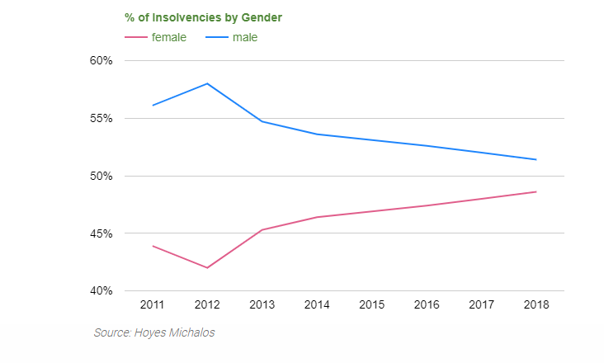
As outlined in our 2017 report on Women and Bankruptcy, despite carrying 21% less unsecured debt than male debtors, women face an elevated risk of filing insolvency due to 3 primary factors:
- Income disparity as women debtors earn less than male debtors. Jane Debtor’s take-home pay is 4.7% below male debtors, while her household income is 6.9% lower.
- Women are much more likely to be living in a single income household with dependents. More than one in four (26%) female debtors were lone-parents compared to one in 12 male debtors (8%). Whether divorced (26% for female debtors as compared to 20% for male debtor) or single, Jane Debtor is struggling financially as the primary income earner on a lower household income and uses debt to make ends meet.
- Higher exposure to student debt. In 2018, more than one in five (22%) female debtors filed insolvency with student loans compared to 13% for male debtors. With a lower average income combined with a lower rate of consistent employment, women debtors find it more challenging to repay high student loan debt. As a result, Jane debtor owes $15,171 in student loans at the time of her insolvency, 8.2% more than Joe Debtor even though they are roughly the same age and have been repaying their loans for a similar time frame.

Jane/Joe Debtor | Female | Male
% of all debtors | 49% | 51%
Average age | 43.0 | 43.3
Unsecured debt | $43,414 | $54,835
Average debtor income | $2,467 | $2,589
Average household income | $2,885 | $3,100
Unsecured debt-to-income | 147% | 177%
% employed | 78% | 84%
% divorced | 26% | 20%
% with dependant(s) | 42% | 29%
% lone-parents | 26% | 8%
% with student debt | 22% | 13%
Average student debtª | $15,171 | $14,021
a - those with student loans

AGE – More Younger Debtors
The average insolvent debtor in 2018 was 43.2 years old, younger than 43.5 in 2017. As noted in our earlier section on Millennials filing insolvency, the percentage of young debtors has increased while the percentage of debtors over 40 has declined. Debtors aged 30 to 39 make up the largest age group of filers.
Age Distribution | 2016 | 2017 | 2018
18–29 | 14% | 16% | 15%
30–39 | 28% | 29% | 30%
40–49 | 26% | 25% | 25%
50–59 | 20% | 18% | 18%
60+ | 12% | 14% | 12%

MARITAL STATUS – Much More Likely to Be Single
Joe Debtor is now much more likely to be single, a significant shift from prior years. Until 2016, Joe Debtor was more likely to be married. In 2018, 42% of all debtors were single, while 32% are married. We also see a decline in the percentage of debtors who are divorced or separated at the time of insolvency.
Marital Status | 2016 | 2017 | 2018
Single | 35% | 39% | 42%
Married / Common Law | 36% | 34% | 32%
Divorced / Separated | 27% | 24% | 23%
Widowed | 3% | 3% | 3%

Once again, the rise in insolvencies among Millennials are impacting marital trends among insolvent debtors. With more young debtors filing insolvency, they are much more likely to be single. In addition, married (and often divorced) couples tend to be homeowners, who have been able to avoid filing insolvency by refinancing their home mortgage to deal with their family debts.

FAMILY SIZE – Lone-parents Face Higher Insolvency Risk
Continuing the trend of our report from 2016, lone-parents account for 17% of all insolvent debtors. Lone-parents are at a substantially higher risk of filing insolvency than dual-parent families. Lone-parent households have an average household income of $3,005, 31.7% below that of two-parent households. Lone-parents owe, on average $41,410, compared to $56,713 for two-parent debtors.
Many lone-parents are balancing both student debt repayment and family expenses on a single income; 26% of lone-parents had student debt in 2018, compared to 19% for two-parent households.
Lone-parents are also more likely to turn to payday-loan style cash advances to makes ends meet. More than 4 in 10 (44%) lone-parent debtors have at least one payday loan, compared to 34% of two-parent households.
Household Size | 2016 | 2017 | 2018
1 | 50% | 53% | 52%
2 | 21% | 22% | 21%
3 | 13% | 11% | 12%
4 | 10% | 9% | 10%
5 | 4% | 4% | 4%
6 or more | 2% | 2% | 1%
Average household size | 2.0 | 2.0 | 2.0
% lone parents | 15.8% | 14.9% | 16.7%

INCOME PROFILE – Not Growing Fast Enough
After several years of declines, Joe Debtor’s income is increasing. In 2018, the average debtor’s monthly take-home pay was $2,530, an increase of 4.5% over 2017.
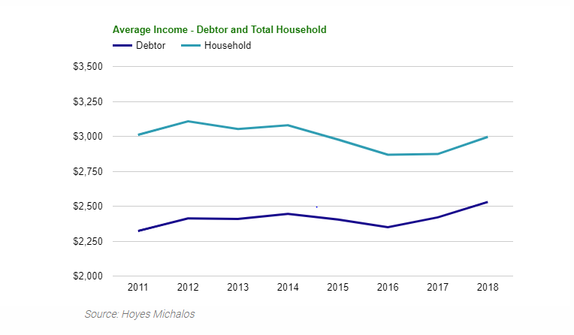

However, this income growth is not enough to cover rising debt repayment. In 2018, Joe Debtor had just $273 in household income available to make monthly debt payments on his unsecured debt, after paying for housing, transportation and living expenses. This is less than the monthly interest payments on $49,289 in debt. Even at a modest blended rate4 of 27%, including high-cost installment and payday loans, his minimum interest costs are $1,115 per month.
And this budget deficit is deteriorating. Despite a growth in income, the amount of money Joe Debtor has available at the end of the month to put towards debt costs remained at 9.1% of total household income in 2018 compared to 2017, down from 9.9% in 2016, while his average debt increased 0.4% in 2018. Factor in interest rate increases and more high-cost payday and installment loans, and his average interest costs are increasing at an even higher rate.
Increased use of high-interest debt and rising interest rates make it harder to keep up with debt repayment for long. That is why we see a decline in the debt-to-income ratio for the average insolvent debtor. In 2018, Joe Debtor owed $1.62 in unsecured loans for every dollar of income he earned, less than the $1.69 it took to trigger insolvency in 2017 and $1.80 in 2016.
Income | 2016 | 2017 | 2018
Debtor income | $2,350 | $2,420 | $2,530
Household income | $2,868 | $2,873 | $2,996
Unsecured debt-to-income | 180% | 169% | 162%
Income available to service debts | $285 | $261 | $273
Income available as % of household income | 9.9% | 9.1% | 9.1%
% employed | 78% | 79% | 81%

Joe Debtor is living paycheque to paycheque, which is why he uses debt to pay for everyday living costs. He spends 40% of his household income on housing, substantially more than the maximum 35% recommended by financial experts. Transportation costs take up another 19% of his income, close to the recommended maximum of 20%. His personal and living costs consume 31% of his income, significantly more than the 20% recommended maximum. With just 9.1% of his income to cover debts (an amount which is insufficient to cover even the monthly interest costs) he has zero left over for savings or creating an emergency fund. This creates a cycle of debt reliance that leads to the use of payday loans, multiple credit cards and high interest term loans.
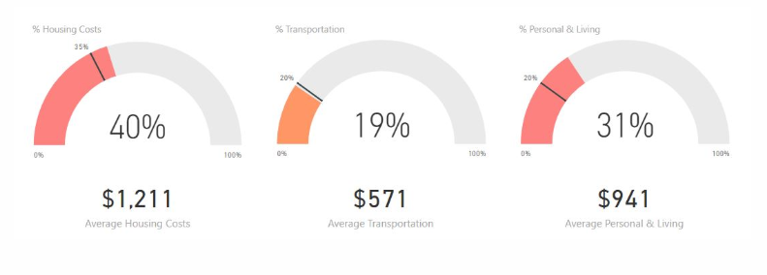

CREDIT PROFILE
The average insolvent debtor in 2018 owed $49,289 in unsecured debt. Average total debt rose marginally, up 0.4%, however, this was the first increased in total unsecured debt since 2012.
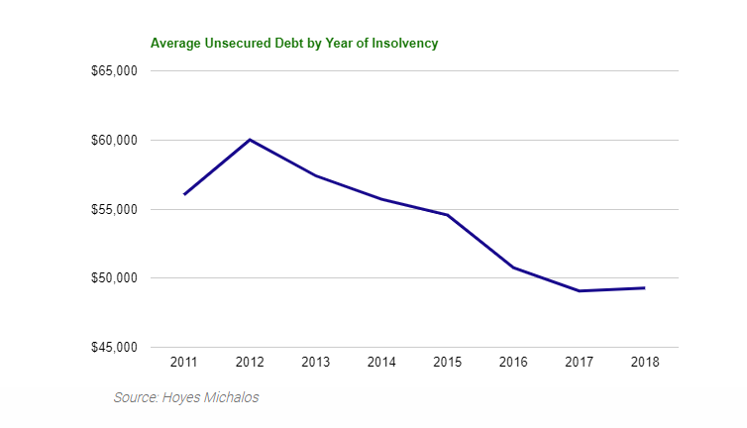
Median debt levels increased even more. Joe Debtor’s median debt was $33,538 in 2018, an increase of 2.8% from $32,620 in 2017.
For information on debt levels for the average insolvent debtor by region see our report on What Insolvency Looks Like By City in Ontario.
In addition to a rise in debt levels, Joe Debtor’s mix of debt has changed. Much more of his debt consists of high-cost debt including payday loans and quick cash installment debt. Below is a summary of debt levels by debt type.

Personal Loans
Joe Debtor owes $16,944, or 34% of his unsecured debt, in personal loans including unsecured term loans, financing company loans, unsecured lines of credit and payday loans.

Payday-Style Loans
Changes in Ontario law in 2017 allowing payday lenders to offer longer repayment terms and low-credit term loans, as well as low credit lines of credit, have increased the use of these types of loans by the average insolvent debtor.
Of all insolvent debtors, 37% carry at least one payday-style loan, up from 32% in 2017. For those who do, the average payday loan debt they owe is $5,174 on 3.9 outstanding loans. The average payday loan debtor files insolvency on only $35,828 in total unsecured debt, significantly less than the average Joe Debtor primarily due to the onerous rates charged on this type of debt.

Credit Card Debt
Nine in ten (90%) insolvent debtors have credit card debt. Of those who do, they owe a total of $17,746 in credit card debt on an average of 3 cards.
Credit card debt increases with age as debtors apply for additional cards and increase their credit limits. Seniors aged 60+, unsurprisingly, have the highest average total credit card debt at $25,784 representing 41% of their overall debts. After a lifetime of accumulating debt, seniors have the highest unsecured debt-to-income ratio of all age groups, at 226%.
Credit Cardsª | Total Debt | # Cards | Average Balance
18-29 | $8,859 | 2.4 | $3,691
30-39 | $13,893 | 2.7 | $5,146
40-49 | $18,625 | 3.1 | $6,008
50-59 | $23,106 | 3.4 | $6,796
60+ | $28,250 | 3.9 | $7,244
a - those with credit card debt

Student Debt
Of insolvent debtors, 18% had a student loan at the time of insolvency, up from 15% in 2017. Those with student debt owed an average of $14,729 representing 32% of their overall debt load.
Student debtors are primarily women. In 2018, more than 6 in 10 (61%) student debt driven insolvencies were filed by women, compared to 39% for men. Women student debtors owed a remaining $15,171 in student loans at the time of filing, compared to $14,021 for men.

Tax Debt
Of insolvent debtors, 38% owe taxes, either property tax or debts owing to Canada Revenue Agency. The average debt they owe is $23,336 with the majority being amounts owing to Canada Revenue Agency.

Causes
Overall economic conditions change the primary reasons people find themselves with more debt than they can repay and ultimately choose to file a bankruptcy or consumer proposal.
With a reasonably healthy economy in Ontario in recent years, the percentage of debtors claiming job or income loss as the primary cause has dropped significantly. In 2018, 81% of insolvent debtors were employed at the time of filing, up from 78% in 2016.
Many more are likely to blame overextension of credit (including the use of payday loans), financial mismanagement and unexpected expenses.
Cause of Insolvency | 2016 | 2017 | 2018
Finances, overuse of credit | 58% | 58% | 61%
Job related, income loss | 55% | 29% | 26%
Illness, injury and health | 14% | 17% | 16%
Marital or relationship breakdown | 14% | 15% | 13%
Business Failure | 6% | 4% | 5%
% employed | 78% | 79% | 81%

Conclusion
Canadians have been addicted to debt for several years now. Since we began our bankruptcy study 8 years ago, total household credit has increased by 43%. Consumer debt, the types of loans dealt with through a consumer proposal or bankruptcy, rose 30% during this same period. 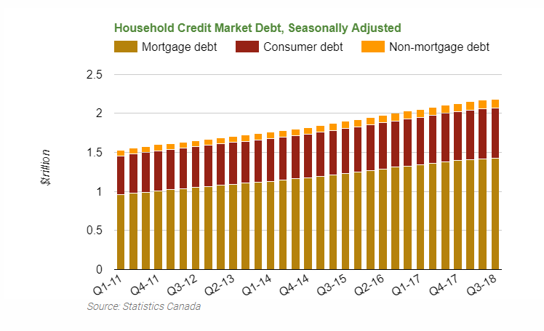
Source: Hoyes Michalos, Statistics Canada
An extended period of low interest rates made all this debt affordable. Low rates provided a refuge against the economic consequences of all this debt. Delinquency rates remained low as did consumer insolvencies, until recently.
Since 2009, Ontario consumer insolvencies were on a steady decline, until 2018. Ontario consumer insolvencies increased 1.8% in 2018, after 9 years of declines. Much of this growth came in the second half of the year, with the 3-month moving average increasing 8.2% by December 2018.
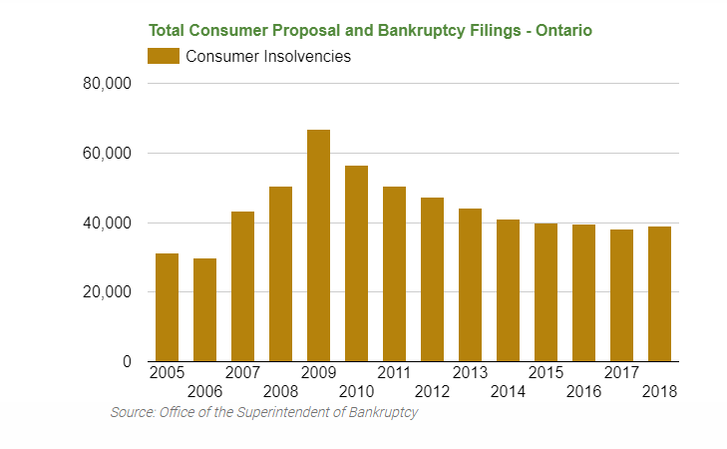
Source: Hoyes Michalos, Office of the Superintendent of Bankruptcy
The growth in household debt is no longer sustainable. Fewer Canadian households will be able to withstand even the smallest change in economic circumstances. Further increases in interest rates combined with a tightening of credit or rise in unemployment will result in a significant increase in the insolvency rate in Ontario. If the downturn is severe, or prolonged, insolvencies could possibly reach levels beyond those seen in 2009.
References
- Generational age definitions for 2018 base Pew Research Centre http://www.pewresearch.org/fact-tank/2019/01/17/where-millennials-end-and-generation-z-begins/
- The Silent Generation: Born 1928-1945 (73-90 years old)
- Baby Boomers: Born 1946-1964 (54-72 years old)
- Generation X: Born 1965-1980 (38-53 years old)
- Millennials: Born 1981-1996 (22-37 years old)
- Post-Millennials: Born 1997-Present (0-21 years old)
- Annual percentages extrapolated and calculated by Hoyes Michalos from data provided by Statistics Canada, Table: 14-10-0018-01 (formerly CANSIM 282-0002) https://www150.statcan.gc.ca/t1/tbl1/en/tv.action?pid=1410001801
- What is the Maximum Amount of Interest I Can Be Charged in Ontario? https://www.hoyes.com/blog/what-is-the-maximum-amount-of-interest-i-can-be-charged-in-ontario/
- Debt Servicing Costs as calculated by Hoyes Michalos
Joe Debtor | Millennials Debt | Interest Rate | Joe Debtor Debt | Interest Rate
Payday loansª | $2,184 | 347% | $1,919 | 340%
Other personal loans | $12,186 | 13% | $15,025 | 13%
Credit card debt | $10,365 | 19% | $15,905 | 19%
Taxes | $3,480 | 5% | $8,835 | 5%
Student loans | $4,369 | 7% | $2,597 | 7%
Other debts | $3,149 | 25% | $5,008 | 25%
Estimated blended rate | $35,733 | 35% | $49,289 | 27%
Estimated monthly interest | $1,033 |  | $1,115
a – average for all debtors, blended rate between traditional & installment
- Calculated by Hoyes Michalos from data provided by Statistics Canada, Table: 17-10-0005-01 (formerly CANSIM 051-0001) https://www150.statcan.gc.ca/t1/tbl1/en/cv.action?pid=1710000501

